FOR IMMEDIATE RELEASE CONTACT: Kim Ina
swc@swcfoundation.org
(415) 566-3487

SPORTS FOR THE WORLD’S CHILDREN TO HOST 11TH ANNUAL
“THEY ARE WORTHY” BENEFIT SOFTBALL TOURNAMENT

SAN FRANCISCO, May 22, 2008 – The Sports for the World’s Children Foundation (SWC) will host its 11th annual “They Are Worthy” benefit softball tournament the weekend of July 12 and 13 at Moscone Playground in San Francisco. Format will be round robin and/or double elimination for the coed upper and lower divisions, and men’s D/DD/C divisions. Participants are encouraged to bring any used and new sports equipment to support their cause: All donated equipment and proceeds from the tournament go to providing kids (and communities and schools) with much needed sports equipment, facilities, skills clinics, and mentoring programs. Equipment needed includes baseballs, bases, basketballs, bats, batting gloves, catchers' gear, Frisbees, hats, mitts, soccer balls, softballs, sports trading cards, sports uniforms (at least five alike), volleyballs, volleyball nets, etc. Entry forms can be found at www.swcfoundation.org.

Last year a total of 20 teams participated in the three divisions of the tournament, and participants donated several hundred pounds of sports equipment. The equipment was later transported to communities in Uganda and Mexico, and delivered to more than 1,700 children in 16 schools, leagues, sports clubs, and teams in dire need of sports equipment through SWC’s “Communities Play” sports equipment distribution and volunteer program in March, April, and May of 2008. Ten volunteers from Washington, Ohio, Mississippi, Michigan, and California traveled to Mexico with SWC to help with the sports equipment distribution effort and provide skills instruction, mentoring, and training.

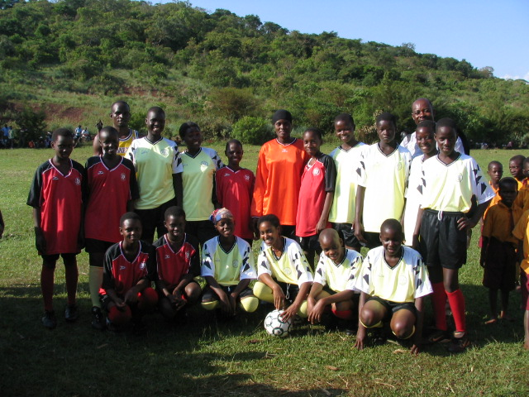

SWC supports girls’ soccer in Hoima District in Uganda, March 25, 2008.
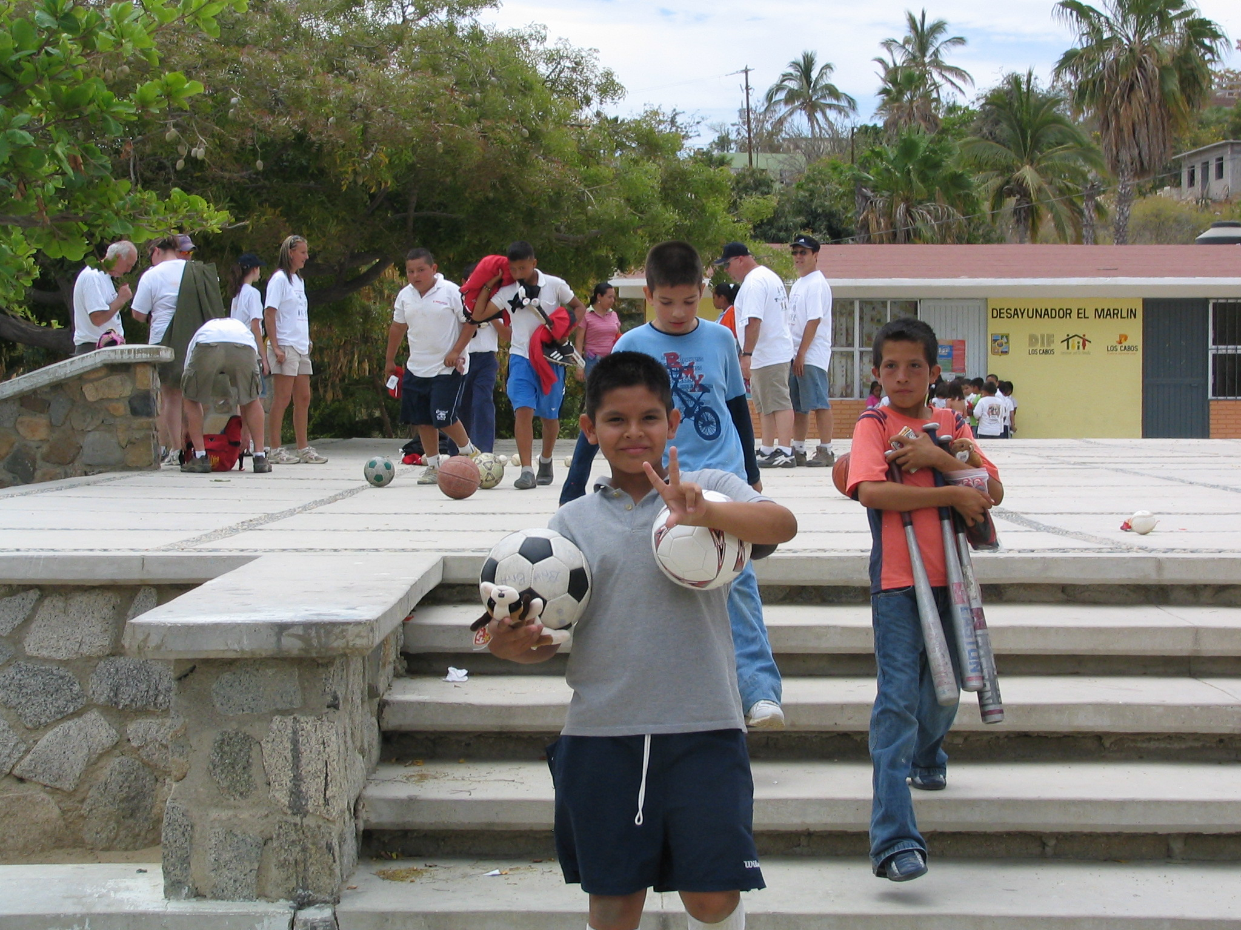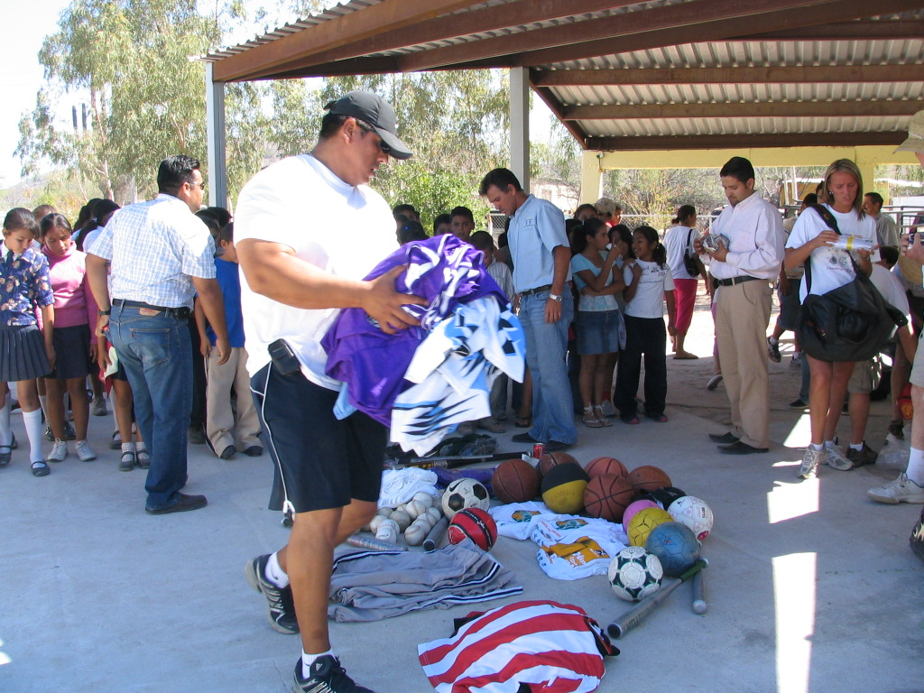

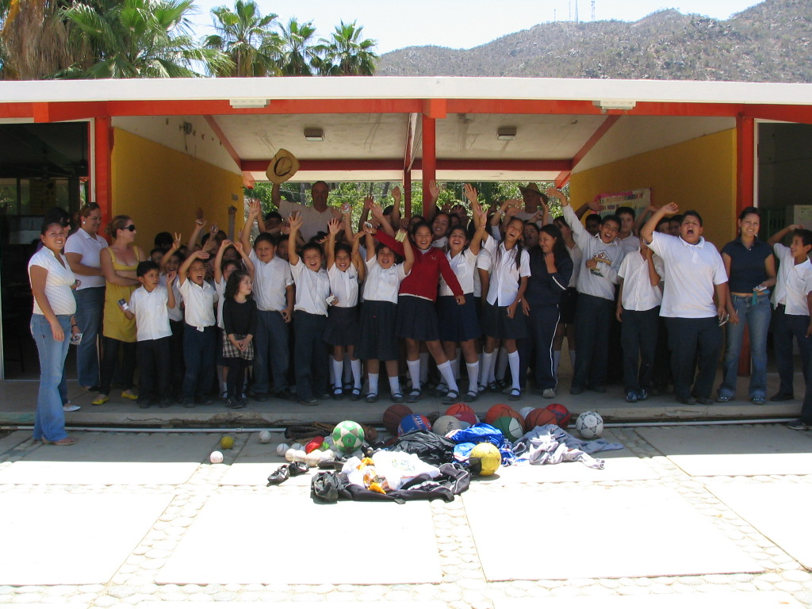

Equipment donations in San Bartolo, Baja California Sur, Mexico, Apr. 28, 2008.

The Sports for the World’s Children Foundation (SWC), based in San Francisco, has been a long time supporter of youth participation in sports locally and abroad. SWC’s mission is to facilitate the creation of ongoing, self-sustaining, quality sports programs for children with limited or no resources. Over the past ten years, SWC has benefited more than 15,100 children, ages 5-18, by providing them with thousands of pounds of sports equipment and sports skills instruction and training through its “Communities Play” Program. SWC’s “Communities Play” Program has received past support from Alaska Airlines, Major League Baseball’s Baseball Tomorrow Fund, and the Kristi Yamaguchi Always Dream Foundation.

Interested individuals, teams, and/or sponsors can contact SWC for more information about the benefit softball tournament, their “Communities Play” sports equipment distribution/volunteer program to Mexico, and/or to order a DVD about their programs at swc@swcfoundation.org, (415) 566-3487.

# # #

